Chapter 14, Problem 63.

Design an active first-order highpass filter with

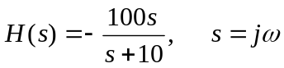

Use a 1-μF capacitor.

